***Supporting information for:***

No evidence for a negative effect of growing season photosynthesis on leaf senescence timing

Xinchen Lu1,2 and Trevor F. Keenan1,2

1, Department of Environmental Science, Policy and Management, University of California, Berkeley, CA 94720, USA

2, Climate and Ecosystem Sciences Division, Lawrence Berkeley National Laboratory, Berkeley, CA 94720, USA

To whom corresponding should be addressed, please contact X. Lu ([xinchen_lu@berkeley.edu](mailto:xinchen_lu@berkeley.edu)) and/or T. Keenan ([trevorkeenan@berkeley.edu](mailto:trevorkeenan@berkeley.edu)).

**Table S1.** Description for the sites used in this study. Lat, Lon indicated the latitude and longitude of the site respectively; and FY and LY presented the first and last year of observations available. Here, we used the International Geosphere-Biosphere Program (IGBP) scheme to identify the biome types of different sites: evergreen needleleaf forest (ENF), grassland (GRA), deciduous broadleaf forest (DBF), open shrubland (OSH), mixed forest (MF), woody savanna (SVA), wetland (WET) and evergreen broadleaf forest (EBF) sites.

|  |  |  |  |  |  |  |
| --- | --- | --- | --- | --- | --- | --- |
| Site | IGBP | Lat | Lon | FY | LY | DOI |
| FI-Hyy | ENF | 61.85 | 61.85 | 1996 | 2014 | 10.18140/FLX/1440158 |
| CA-Obs | ENF | 53.99 | 53.99 | 1997 | 2010 | 10.18140/FLX/1440044 |
| CA-Let | GRA | 49.71 | 49.71 | 1998 | 2008 | 10.17190/AMF/1436318 |
| US-MMS | DBF | 39.32 | 39.32 | 1999 | 2014 | 10.18140/FLX/1440083 |
| US-NC2 | ENF | 35.80 | 35.80 | 2005 | 2017 | 10.17190/AMF/1246083 |
| CA-Ojp | ENF | 53.92 | 53.92 | 1996 | 2010 | 10.17190/AMF/1375199 |
| IT-MBo | GRA | 46.01 | 46.01 | 2003 | 2013 | 10.18140/FLX/1440170 |
| US-EML | OSH | 63.88 | 63.88 | 2008 | 2017 | 10.17190/AMF/1418678 |
| BE-Vie | MF | 50.30 | 50.30 | 1996 | 2014 | 10.18140/FLX/1440130 |
| CA-Oas | DBF | 53.63 | 53.63 | 1996 | 2010 | 10.18140/FLX/1440043 |
| US-Syv | MF | 46.24 | 46.24 | 2001 | 2017 | 10.18140/FLX/1440091 |
| US-Vcm | ENF | 35.89 | 35.89 | 2007 | 2017 | 10.17190/AMF/1246121 |
| NL-Loo | ENF | 52.17 | 52.17 | 1996 | 2014 | 10.18140/FLX/1440178 |
| DE-Hai | DBF | 51.08 | 51.08 | 2000 | 2012 | 10.18140/FLX/1440148 |
| CA-Cbo | DBF | 44.32 | 44.32 | 1994 | 2014 | 10.17190/AMF/1498755 |
| CA-Ca1 | ENF | 49.87 | 49.87 | 1996 | 2010 | 10.17190/AMF/1480300 |
| CA-Gro | MF | 48.22 | 48.22 | 2003 | 2014 | 10.18140/FLX/1440034 |
| US-UMB | DBF | 45.56 | 45.56 | 2007 | 2017 | 10.18140/FLX/1440093 |
| CA-Man | ENF | 55.88 | 55.88 | 1994 | 2008 | 10.18140/FLX/1440035 |
| US-Ha1 | DBF | 42.54 | 42.54 | 1991 | 2012 | 10.18140/FLX/1440071 |
| CA-Ca3 | ENF | 49.53 | 49.53 | 2000 | 2010 | 10.17190/AMF/1480302 |
| US-UMd | DBF | 45.56 | 45.56 | 2007 | 2017 | 10.18140/FLX/1440101 |
| IT-Col | DBF | 41.85 | 41.85 | 1996 | 2014 | 10.18140/FLX/1440167 |
| US-NR1 | ENF | 40.03 | 40.03 | 1998 | 2017 | 10.18140/FLX/1440087 |
| BE-Bra | MF | 51.31 | 51.31 | 1996 | 2014 | 10.18140/FLX/1440128 |
| DE-Tha | ENF | 50.96 | 50.96 | 1996 | 2014 | 10.18140/FLX/1440152 |
| US-Blo | ENF | 38.90 | 38.90 | 1997 | 2007 | 10.18140/FLX/1440068 |
| US-Wjs | SAV | 34.43 | 34.43 | 2007 | 2017 | 10.17190/AMF/1246120 |
| US-SRG | GRA | 31.79 | 31.79 | 2008 | 2017 | 10.18140/FLX/1440114 |
| US-Wkg | GRA | 31.74 | 31.74 | 2004 | 2017 | 10.18140/FLX/1440096 |
| DE-Lnf | DBF | 51.33 | 51.33 | 2002 | 2012 | 10.18140/FLX/1440150 |
| US-Me2 | ENF | 44.45 | 44.45 | 2002 | 2017 | 10.18140/FLX/1440079 |
| US-GLE | ENF | 41.37 | 41.37 | 1999 | 2017 | 10.18140/FLX/1440069 |
| US-Los | WET | 46.08 | 46.08 | 2000 | 2017 | 10.18140/FLX/1440076 |
| US-Ho1 | ENF | 45.20 | 45.20 | 1996 | 2017 | 10.17190/AMF/1246061 |
| DK-Sor | DBF | 55.49 | 55.49 | 1996 | 2014 | 10.18140/FLX/1440155 |
| IT-Cpz | EBF | 41.71 | 41.71 | 1997 | 2009 | 10.18140/FLX/1440168 |
| CH-Lae | MF | 47.48 | 47.48 | 2004 | 2014 | 10.18140/FLX/1440134 |
| US-WCr | DBF | 45.81 | 45.81 | 1999 | 2014 | 10.18140/FLX/1440095 |

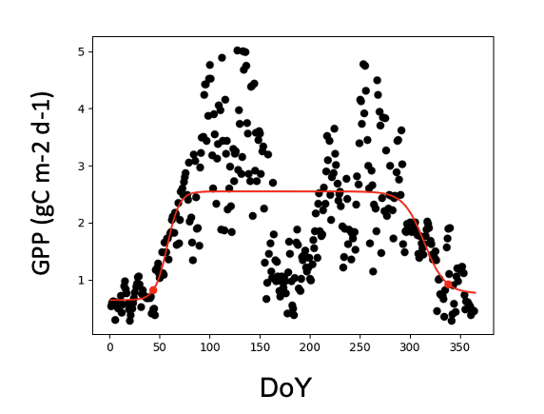

**Fig. S1.** The time series of gross primary productivity (GPP) at the site of US-Vcp in the year of 2007, indicating a double-peaked growing season. We excluded such double-peaked sites.

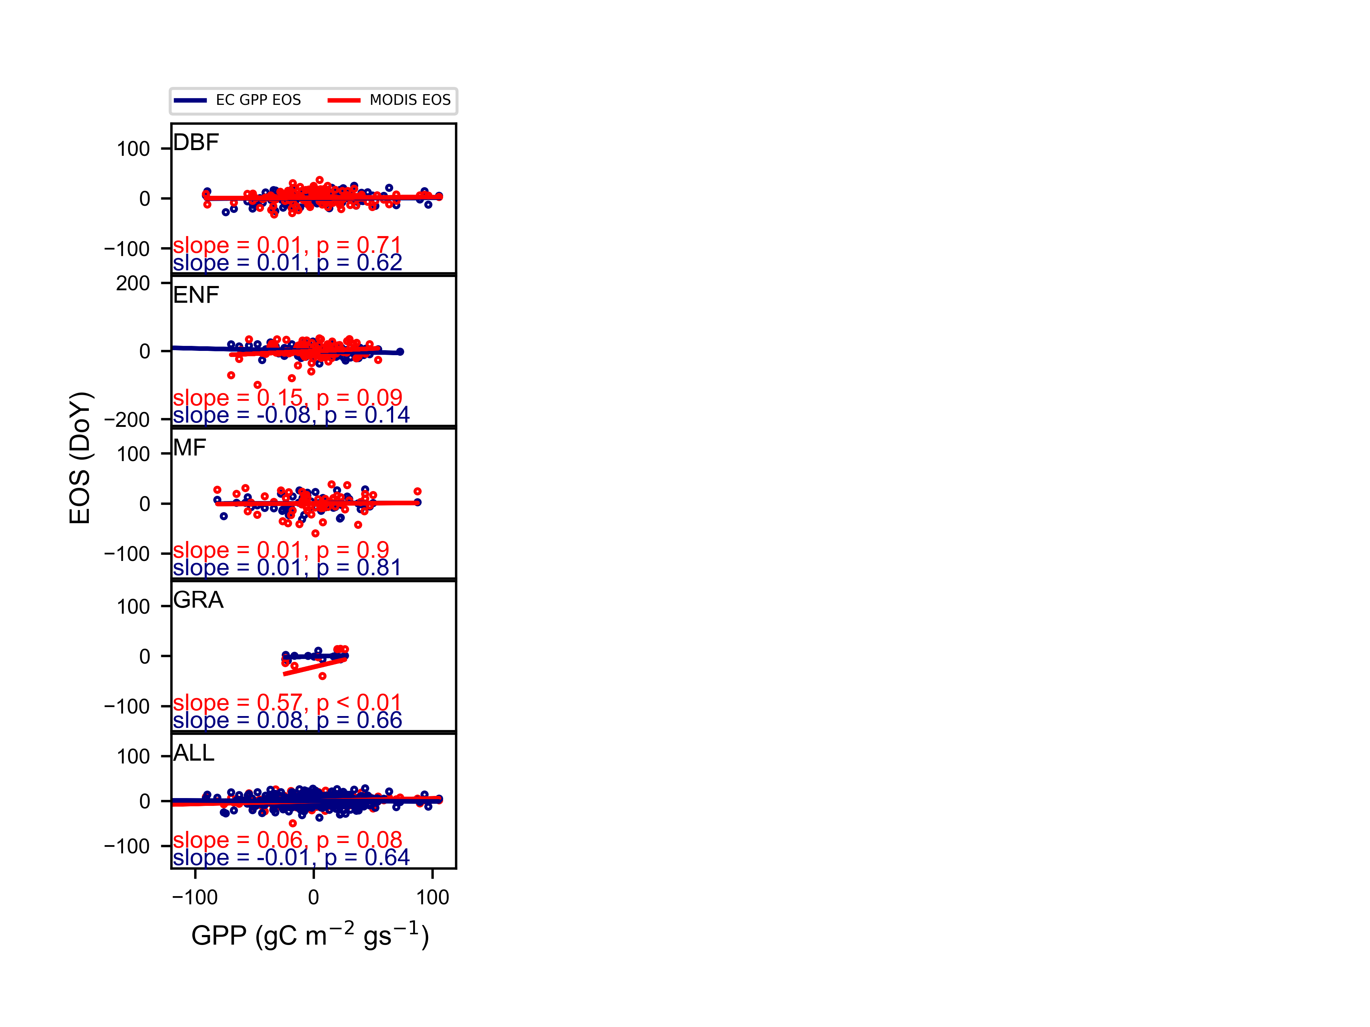

**Fig. S2.** Similar to Fig.1., but using the daytime partitioning method.

**Fig. S3**. The comparison between end of season (EOS) dates estimated from flux tower derived gross primary productivity (GPP) and MODIS EOS in different ecosystems.

**Fig. 4.** The relationship between growing season photosynthesis (GPP) and ground observed leaf senescence or remotely sensed end of season (EOS).